Appendix 1:

Task 1:

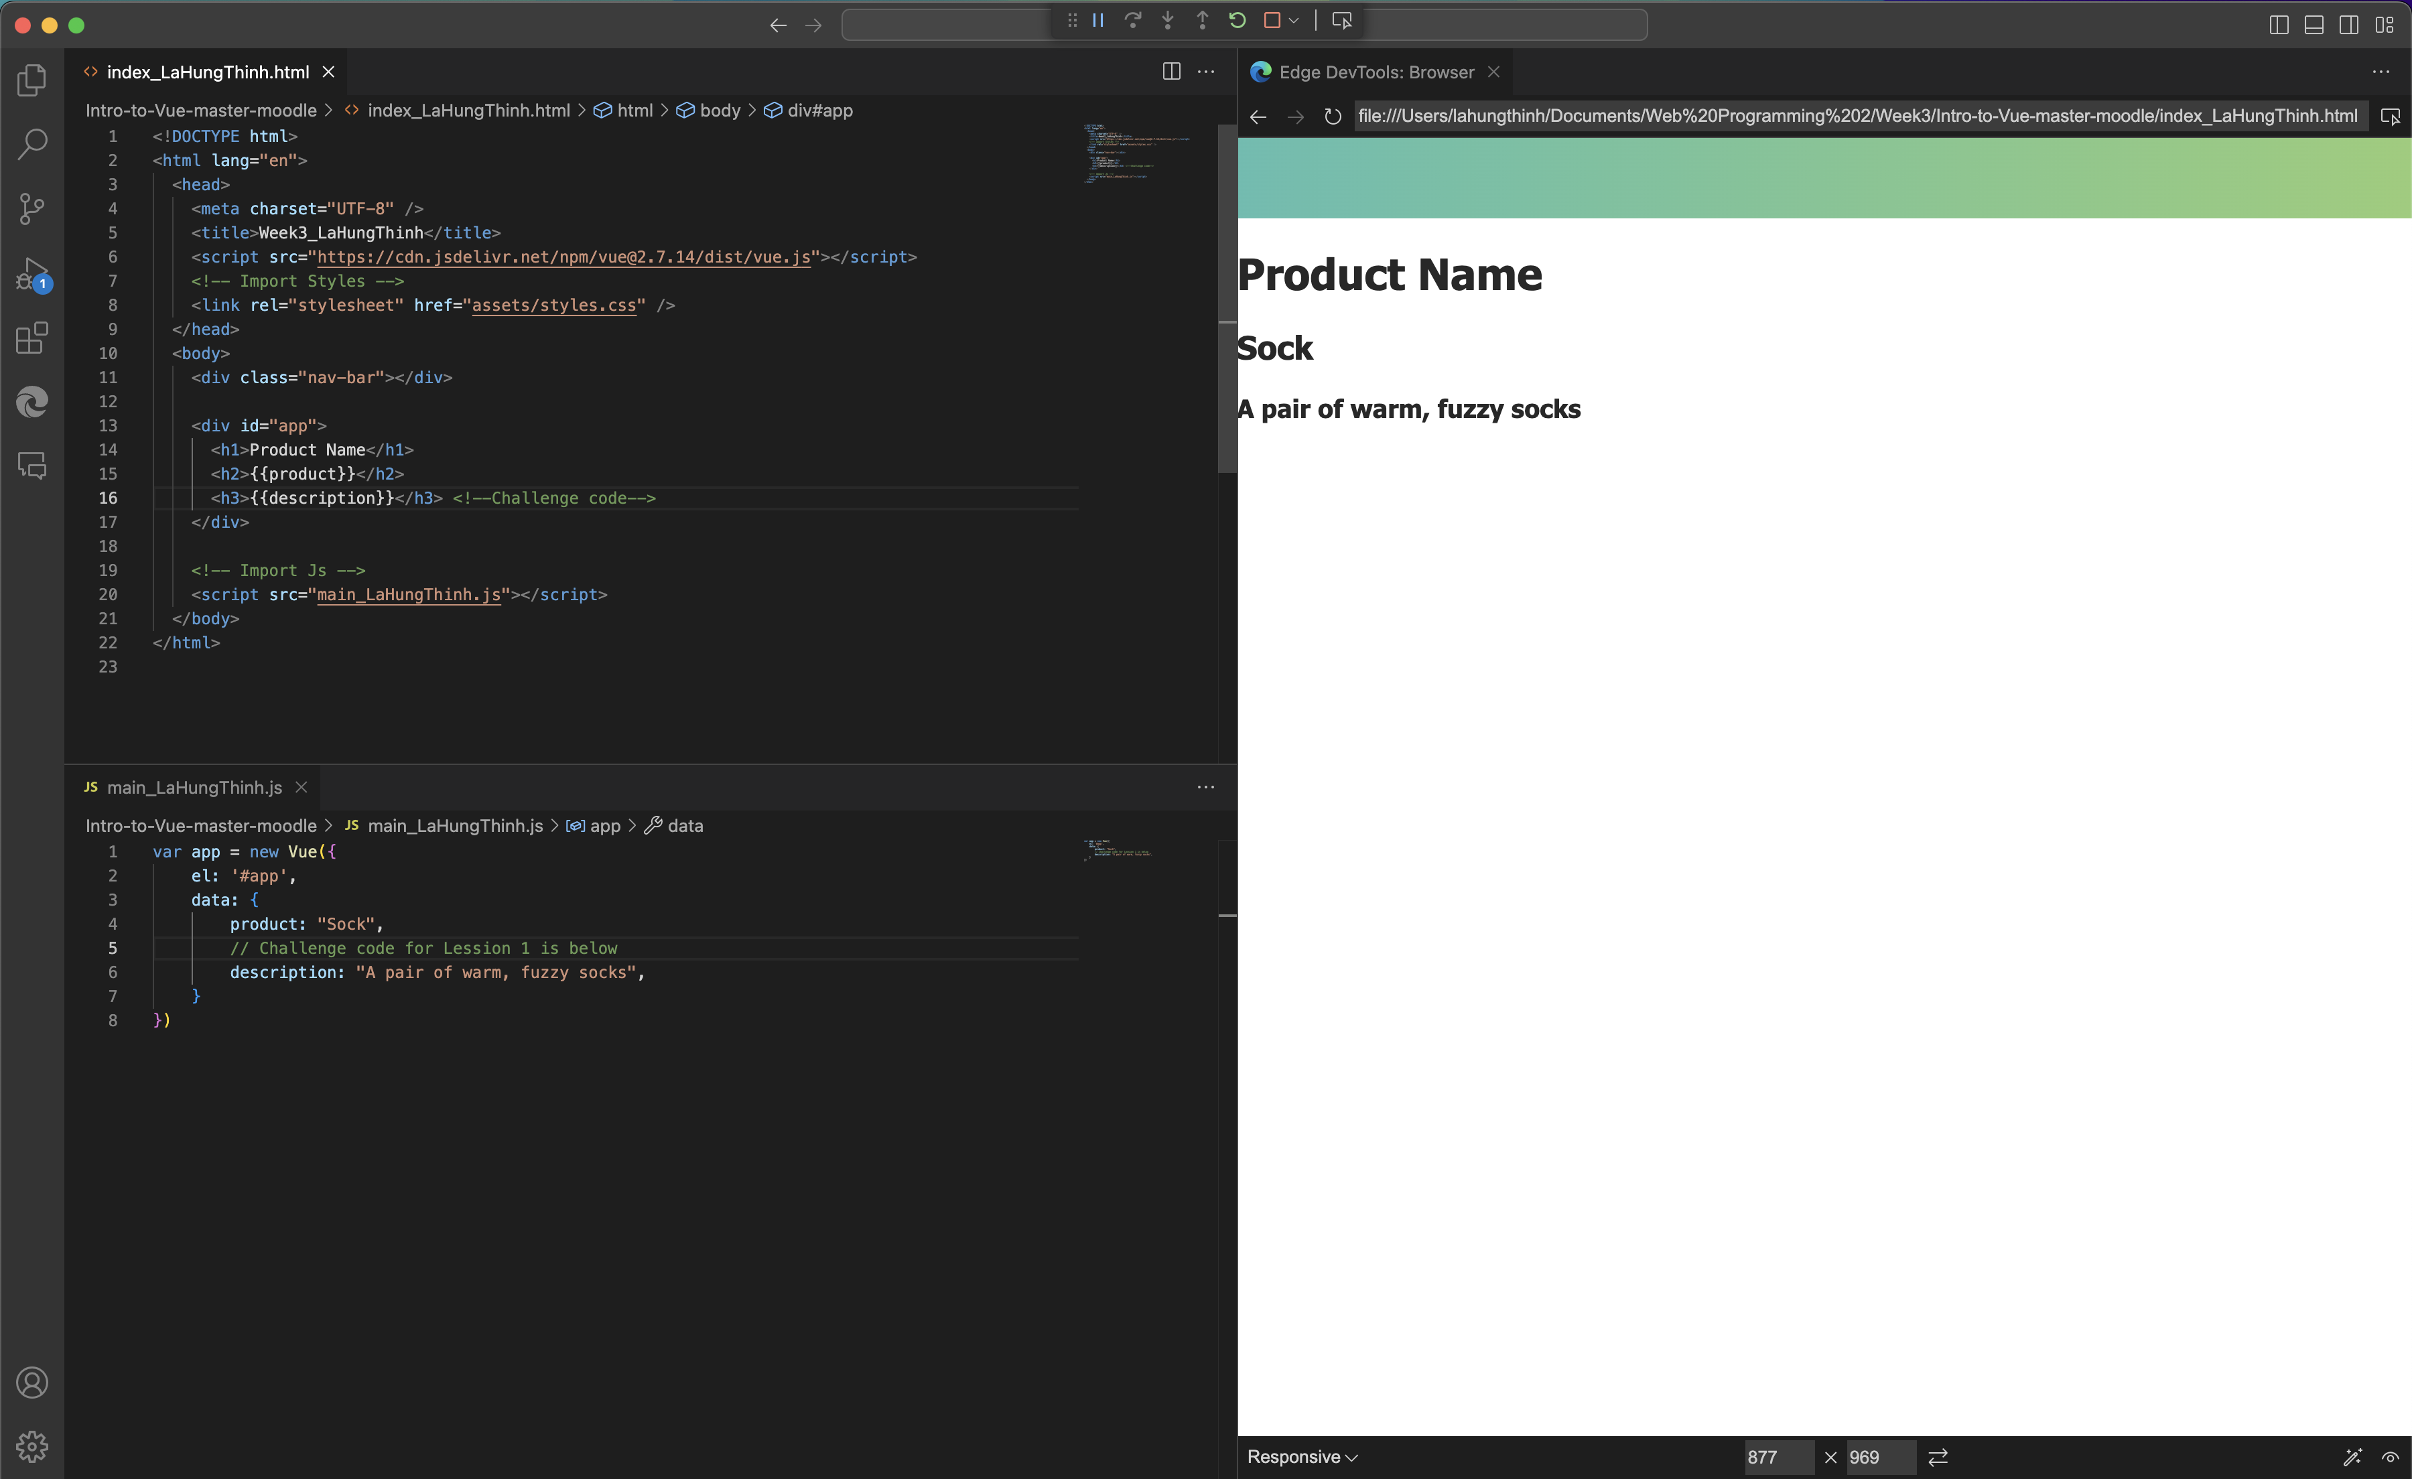

Figure 1. Lesson 1 + Challenge

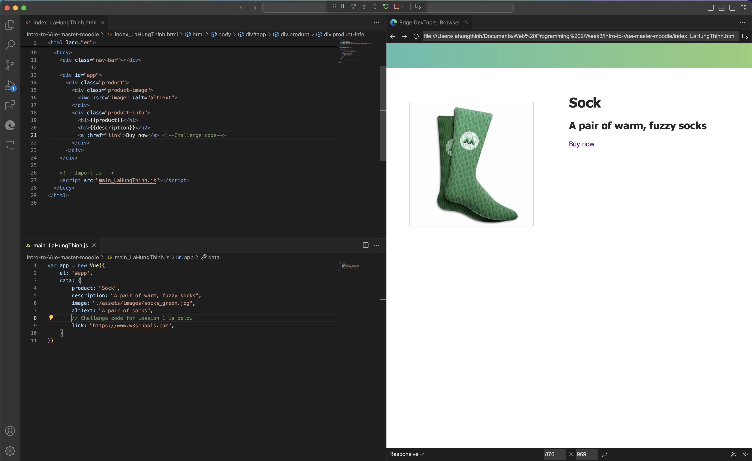

Figure 2. Lesson 2 + Challenge

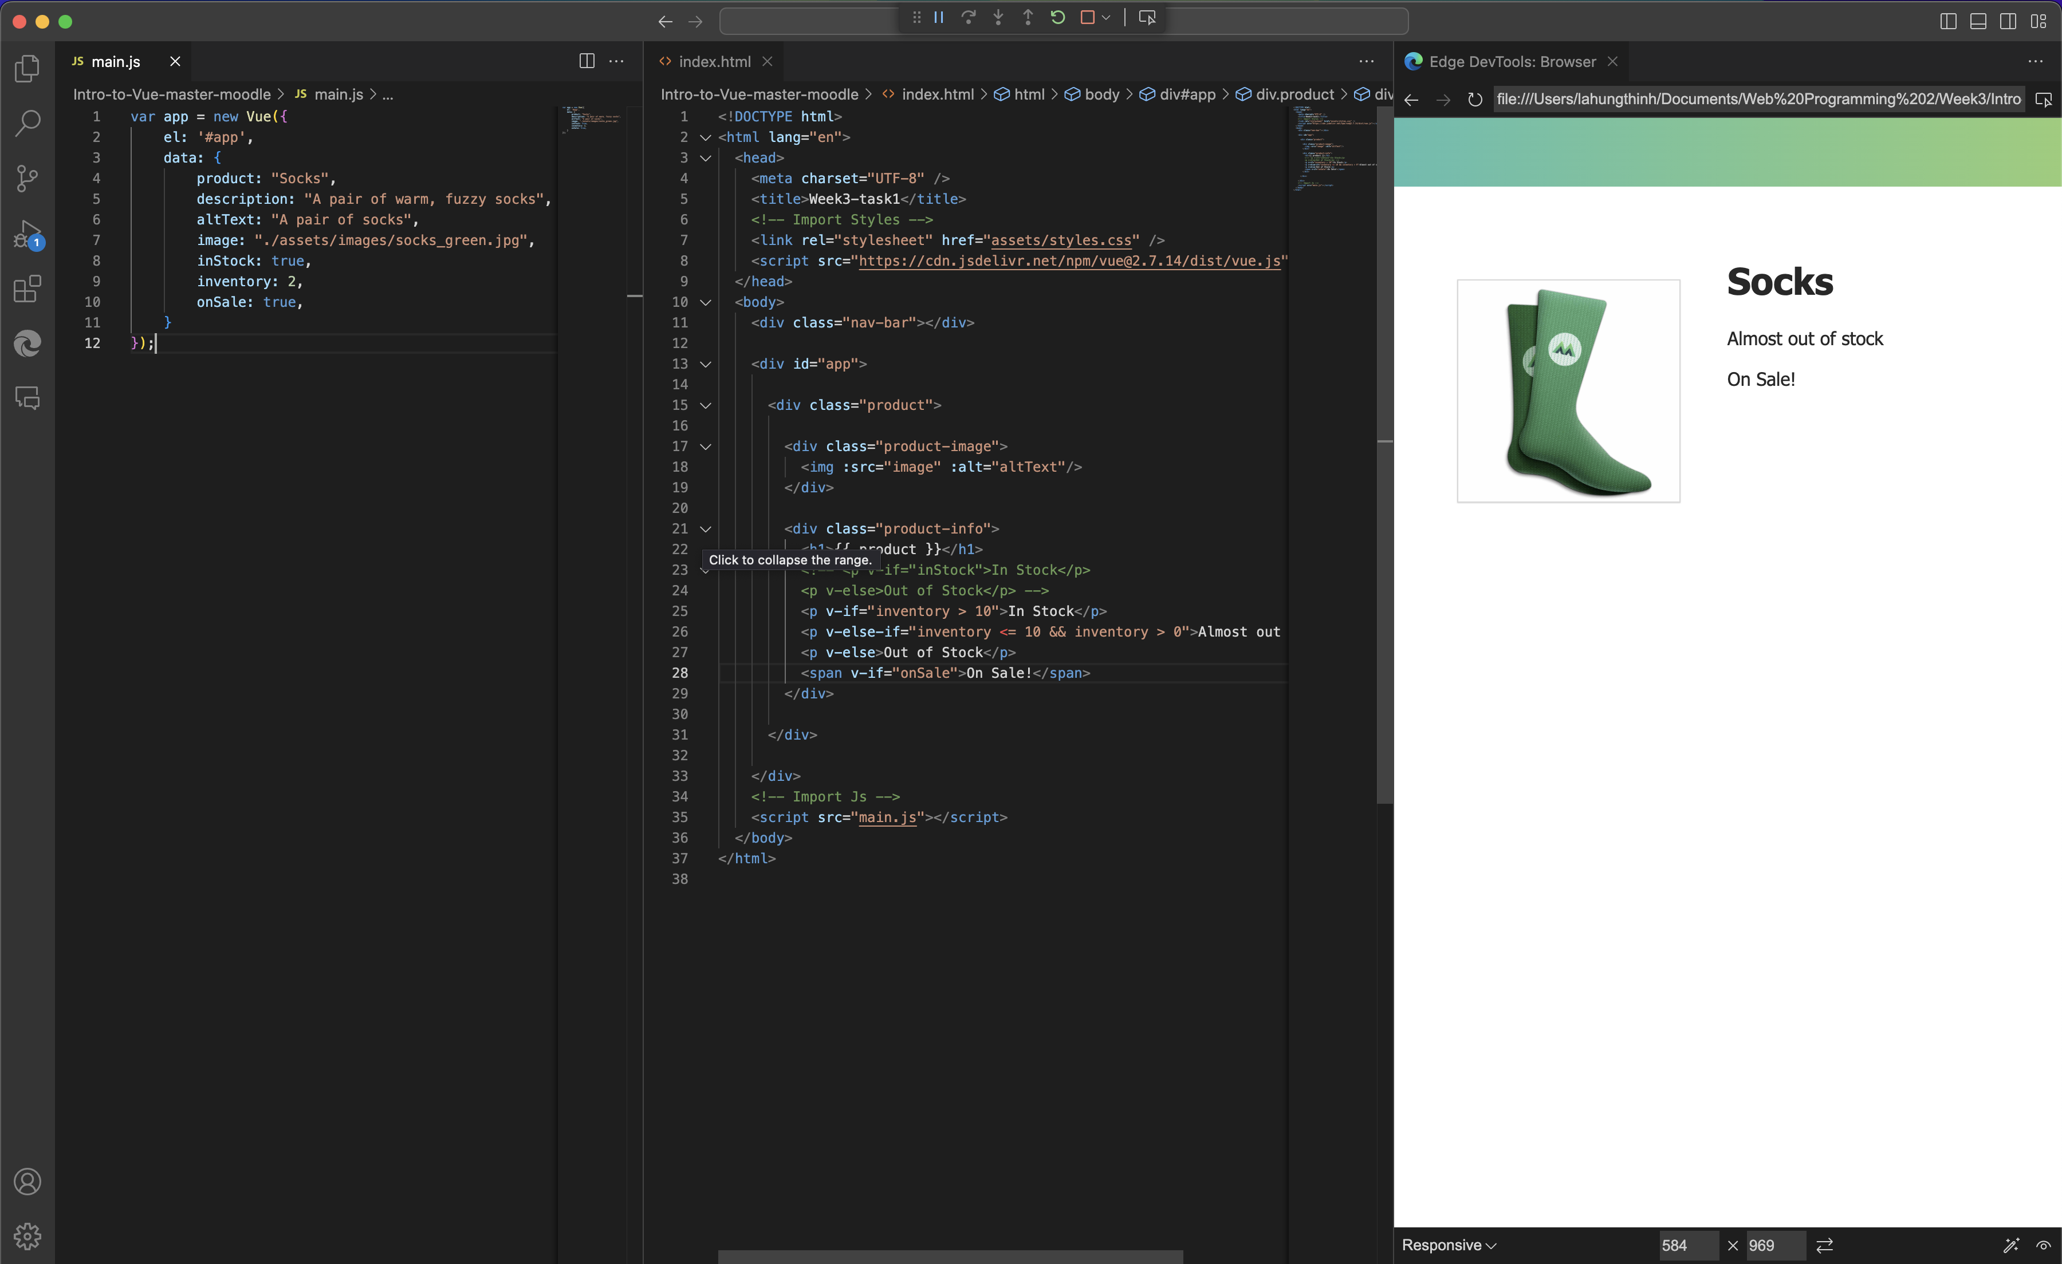

Figure 3. Lesson 3 + Challenge

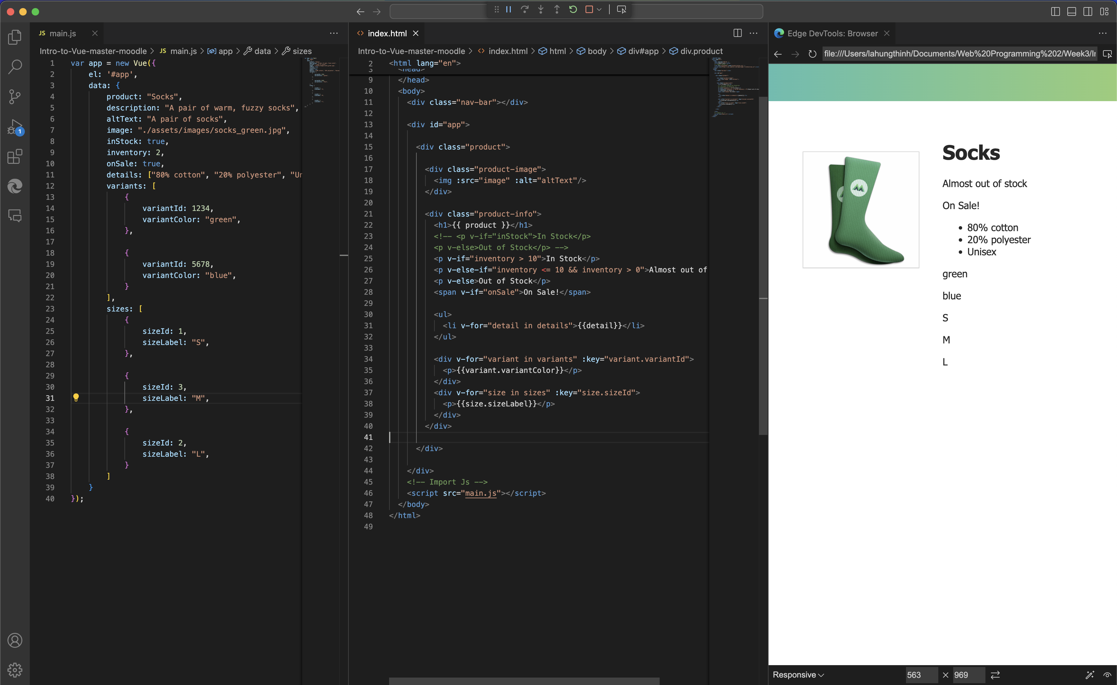

Figure 4. Lesson 4 + Challenge

Explanation:

Throughout these lessons, I’ve gained valuable skills, such as creating and using keys in Vue, integrating them into HTML, binding attributes dynamically, and setting conditions to control the flow of the code. I also learned how to efficiently display all the items in a list directly on the screen.

In Challenge 1, I focused on creating a key within the data object and subsequently displayed it on the webpage. This task was a simple yet crucial step in understanding the basics of Vue data binding.

Challenge 2 was especially enjoyable, as it allowed me to experiment with redirecting users to any website of my choice when they clicked on a hyperlink. It was exciting to play with different URLs and see how they could be dynamically assigned and managed in the code.

For Challenge 3, I created a key named onSale and set its type to Boolean. This was a practical way to control the display of specific information. If the onSale value was true, the webpage would automatically show a message indicating "On Sale!" This taught me how to use conditional rendering effectively based on data states.

Finally, in Challenge 4, I applied concepts I learned from the lesson on creating variants. Instead of creating variants based on color, I customized it by introducing labels, which provided a more flexible and suitable solution for my future coding projects. By making this adjustment, I ensured that the code structure was optimized for later reuse, making it easier to maintain and expand upon as needed.

Appendix 2:

Task 2:

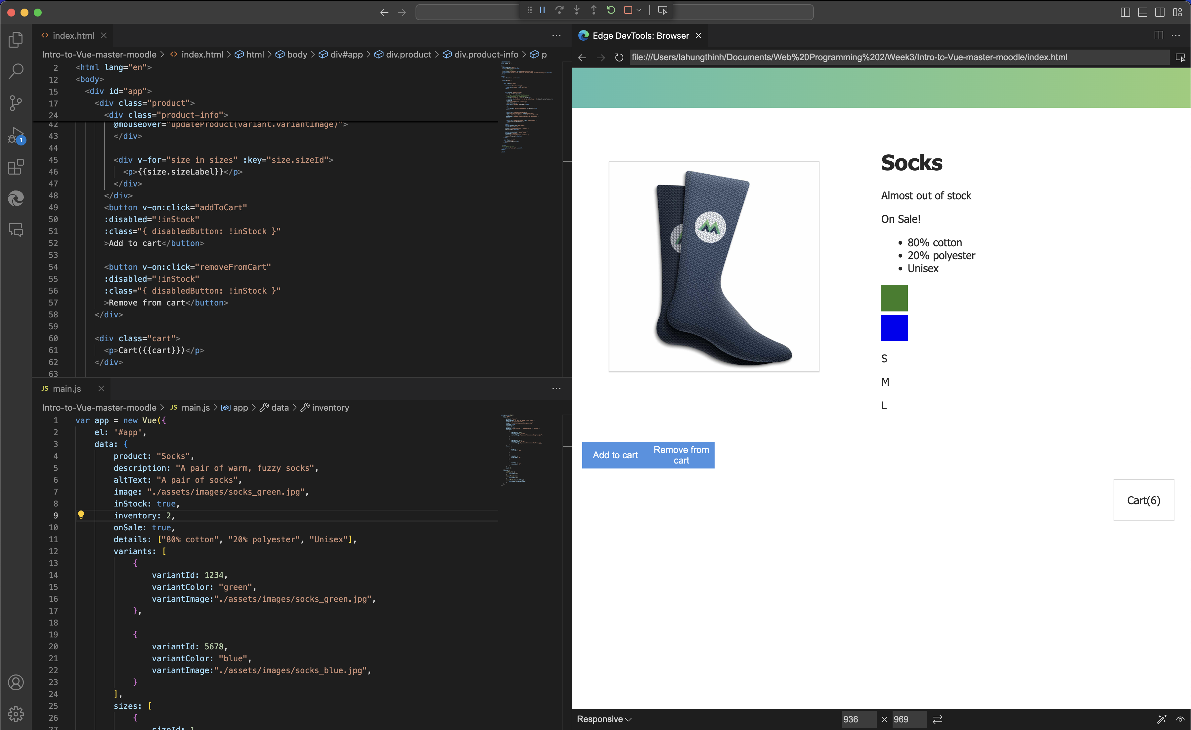

Figure 6. Lesson 5 + Challenge (Part 1)

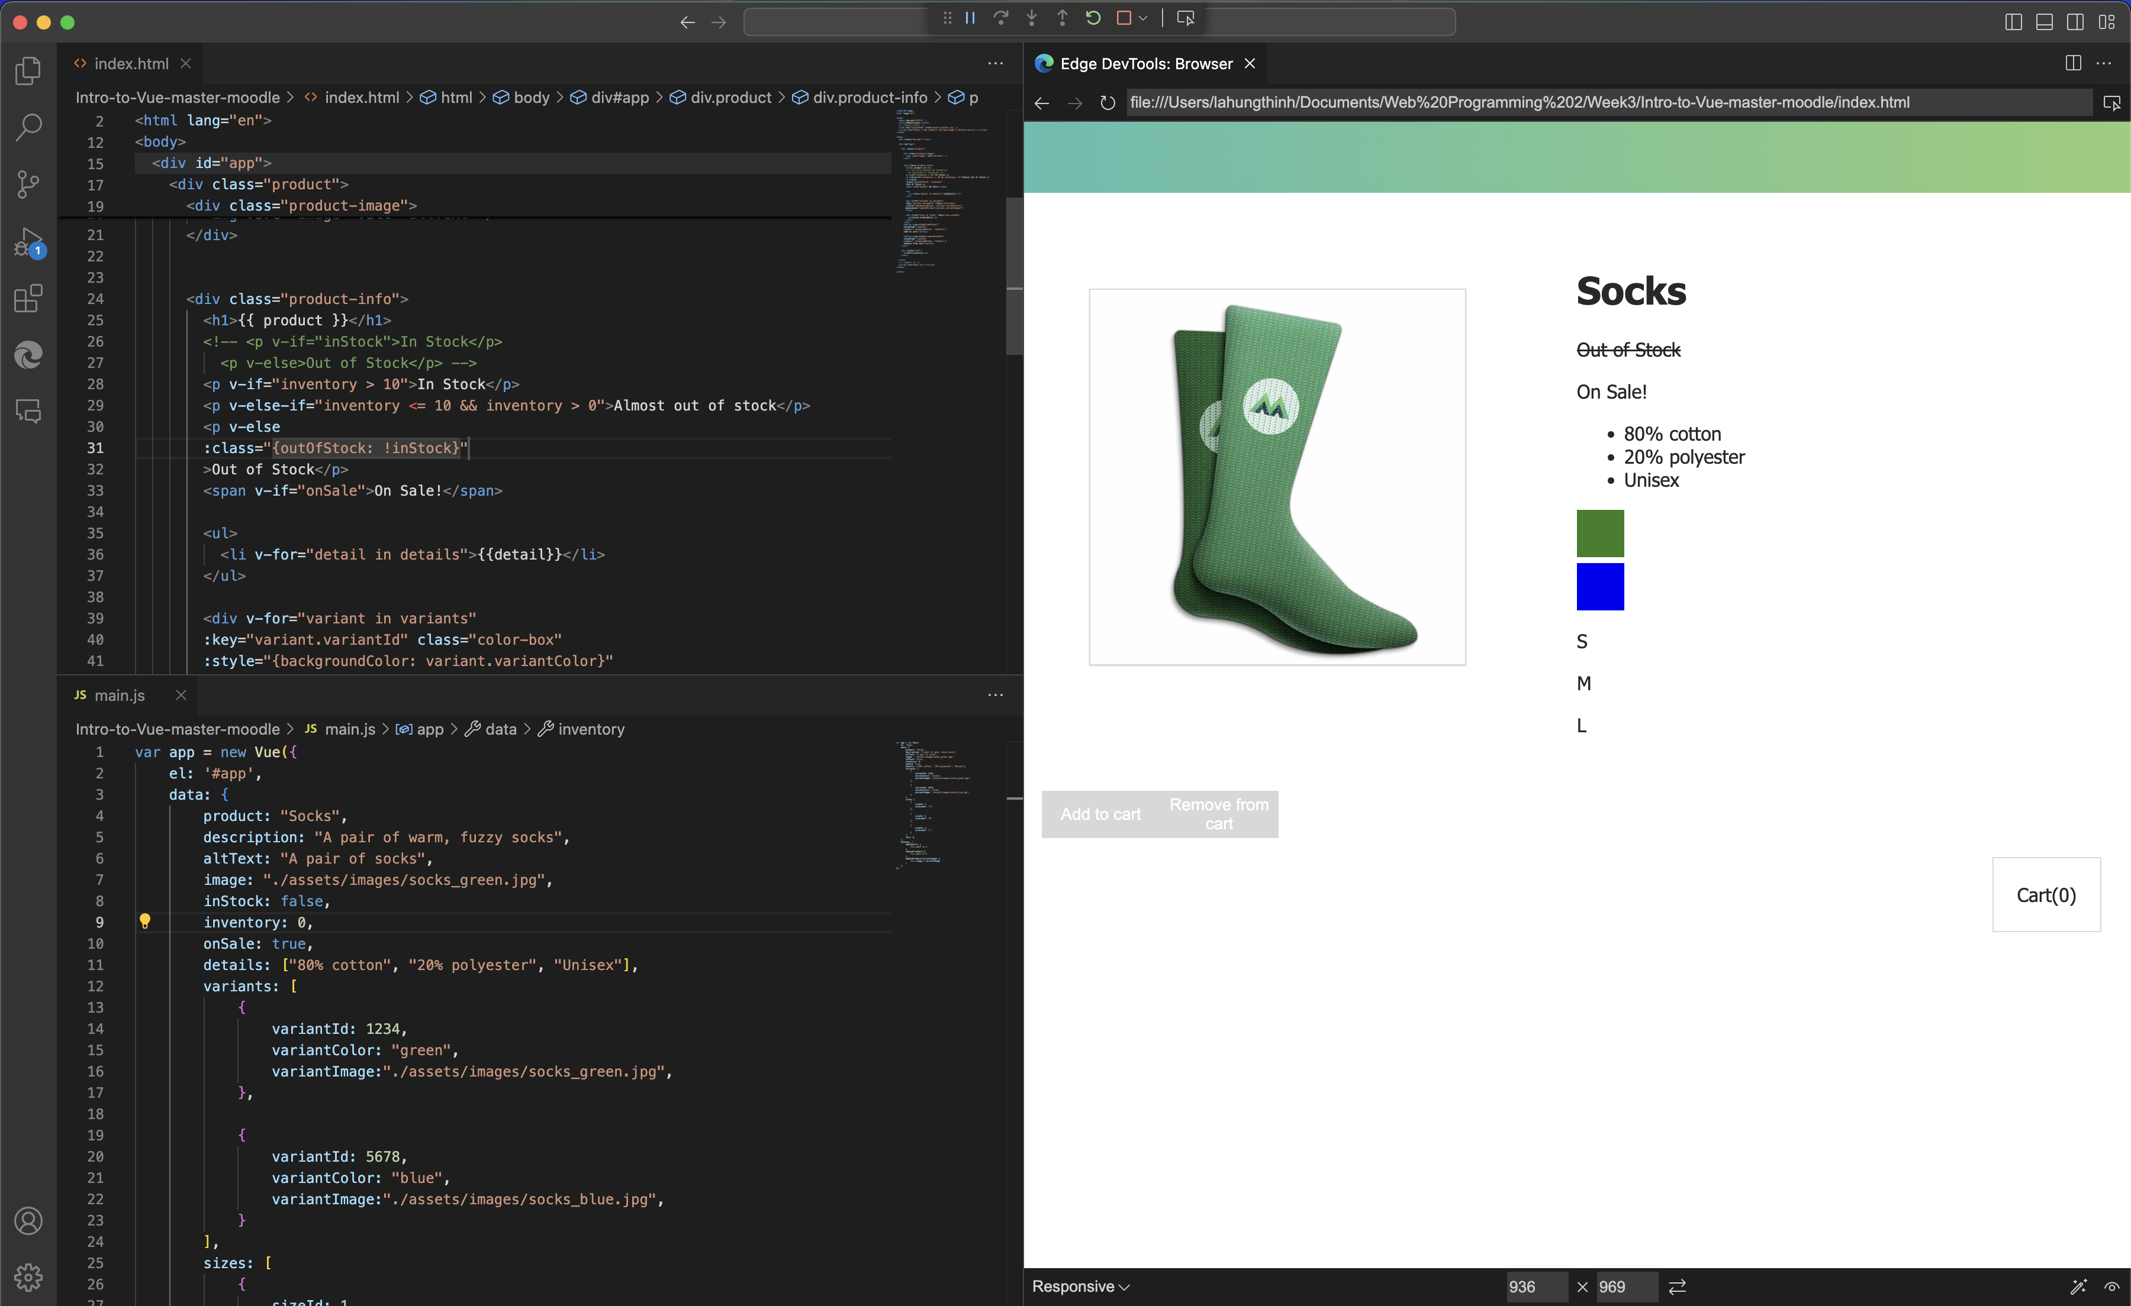

Figure 7. Lesson 5 + Challenge (Part 2)

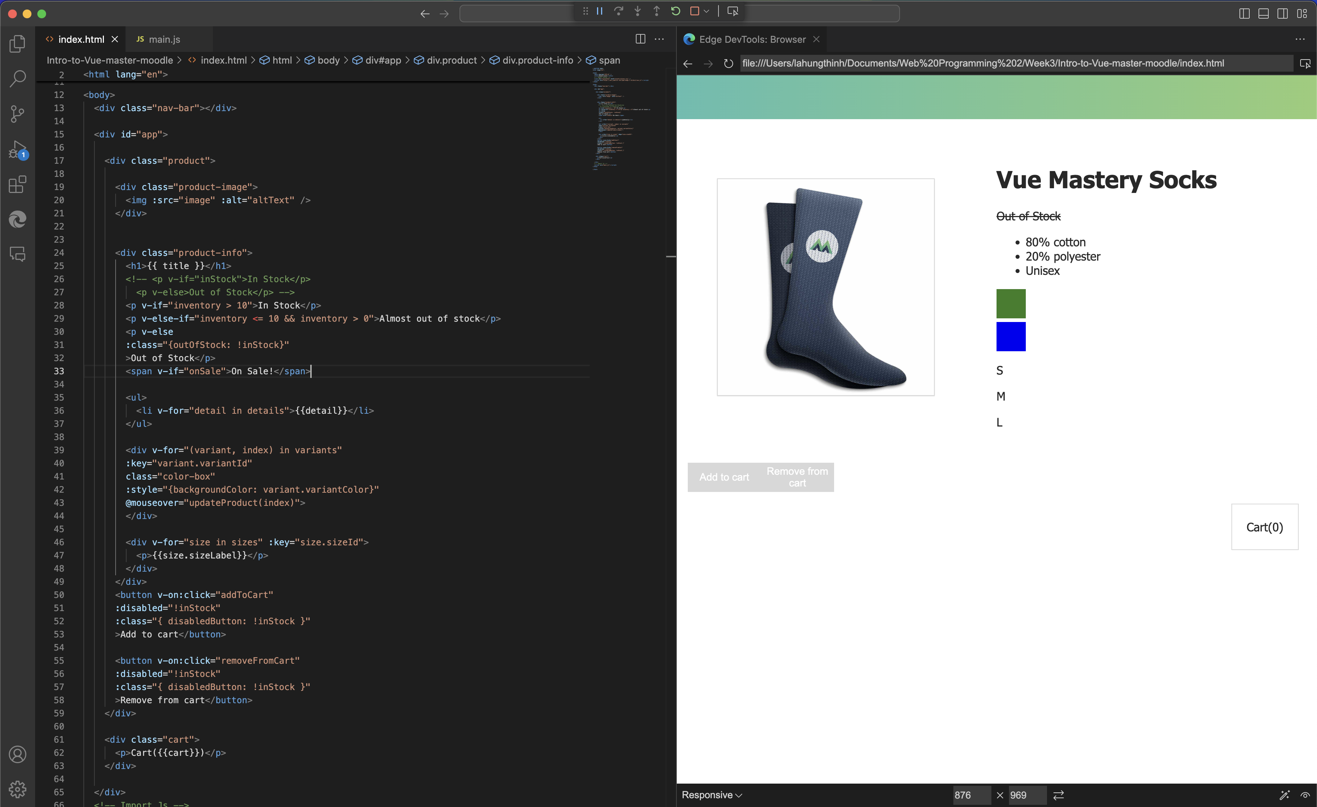

Figure 8. Lesson 6 + Challenge

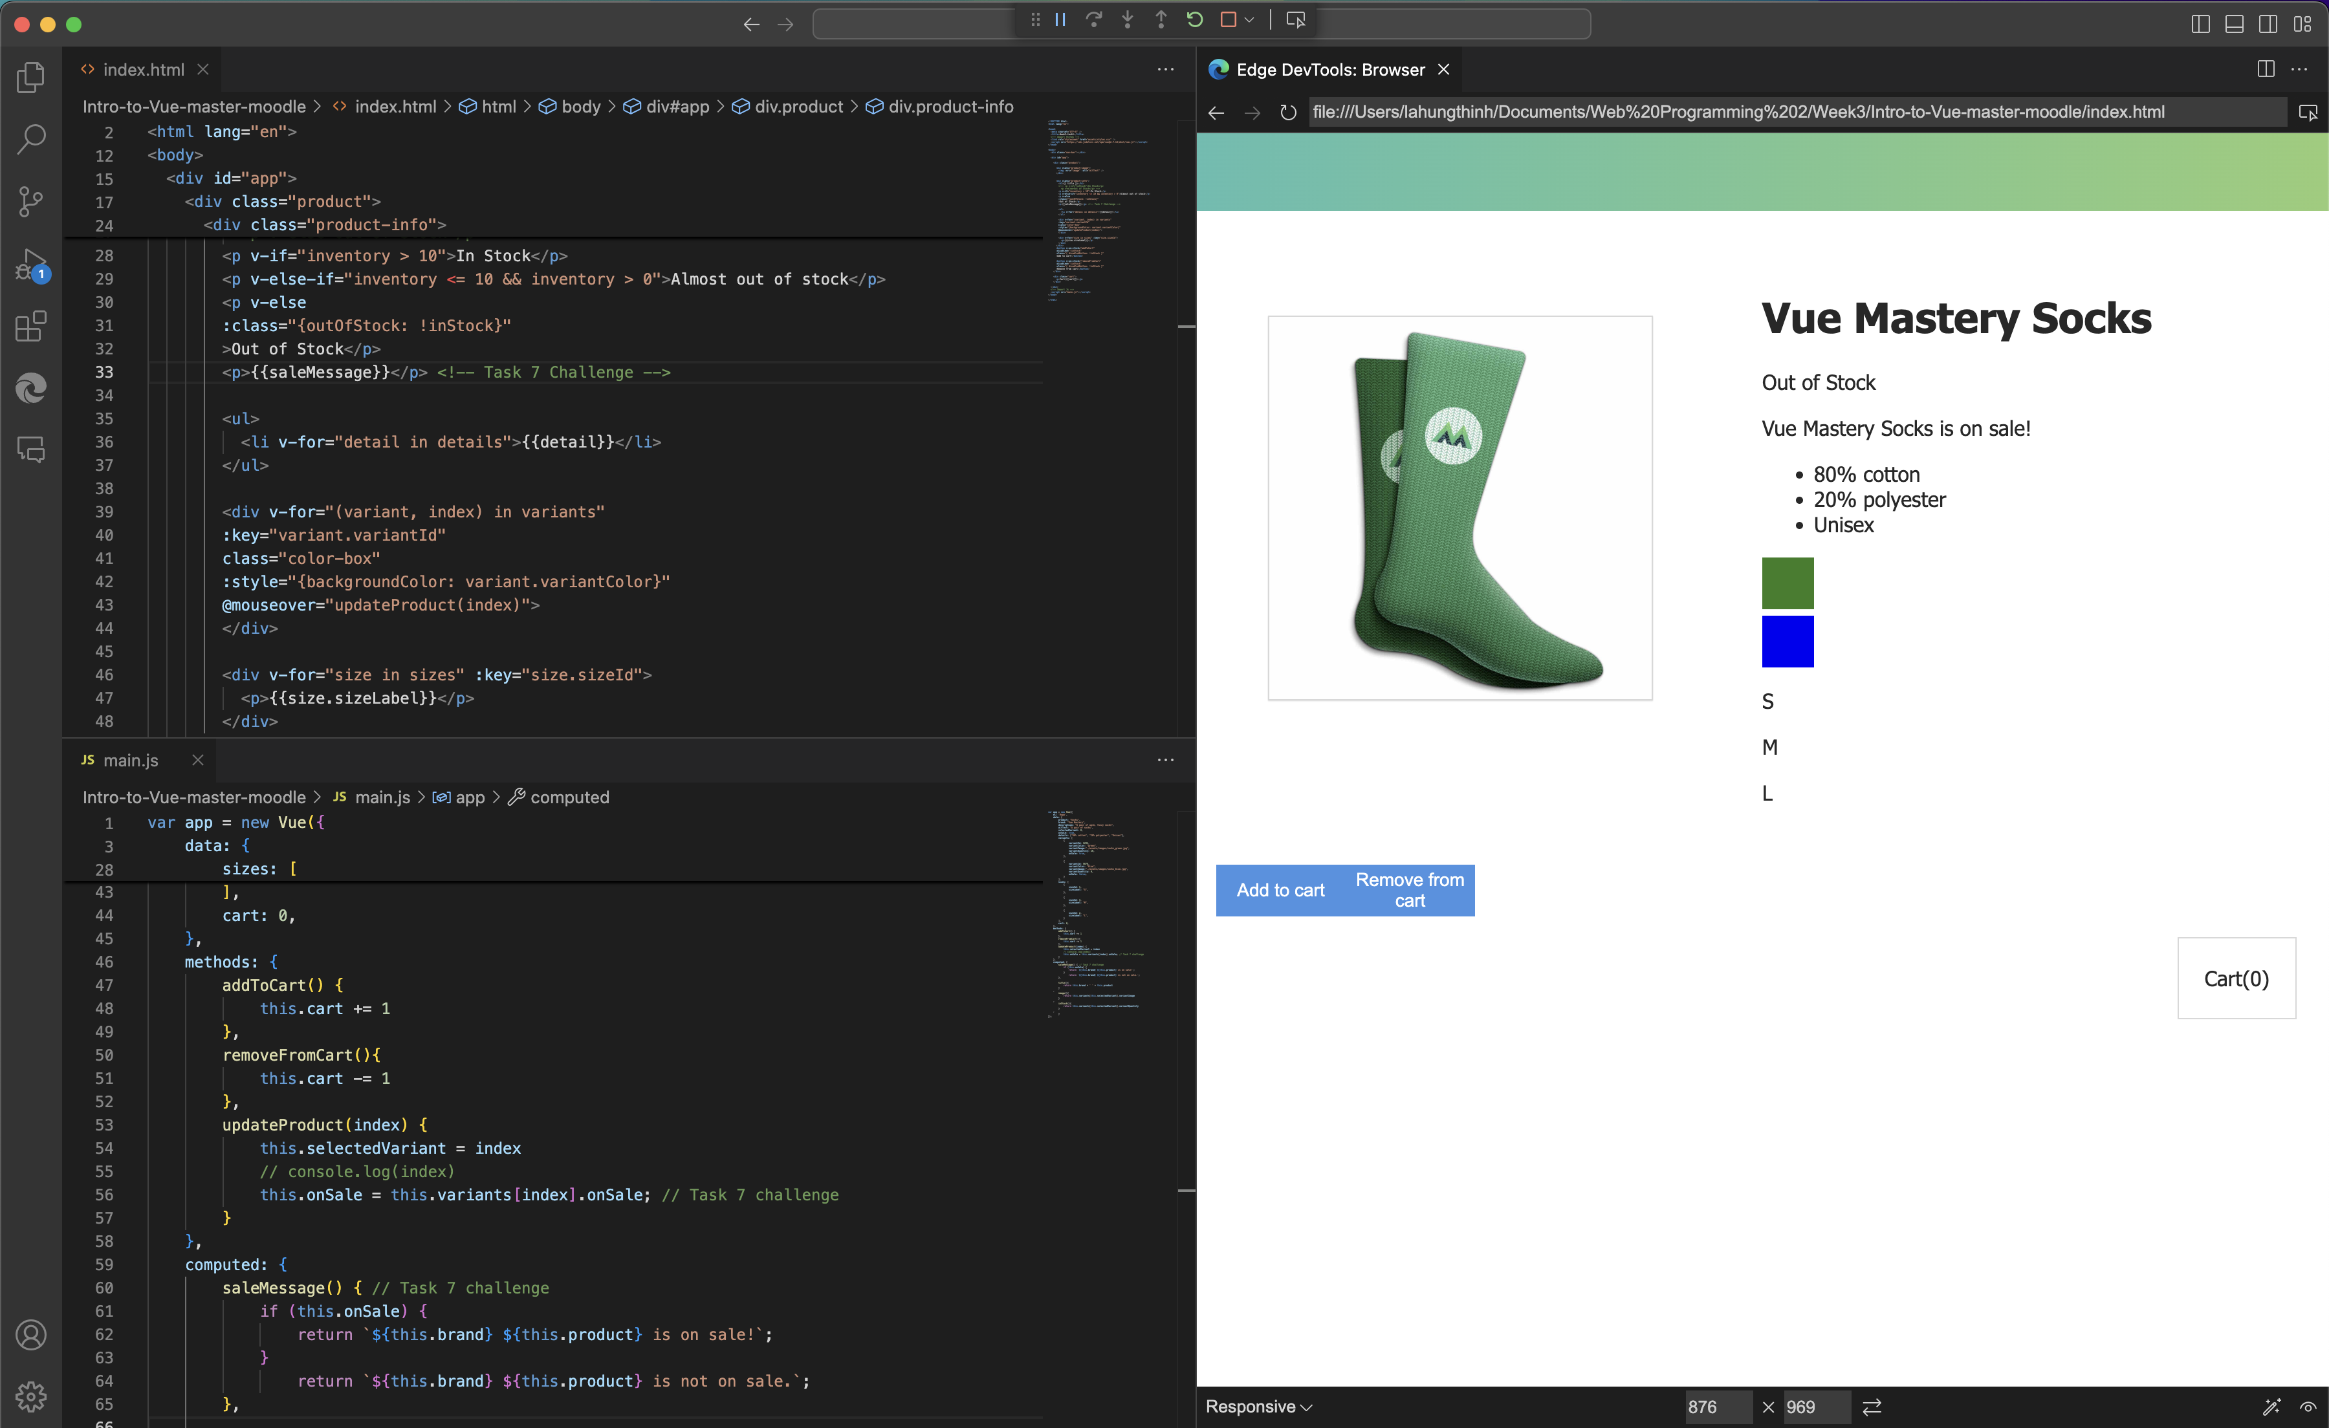

Figure 9. Lesson 7 + Challenge (Part 1)

Explanation:

Through these lessons, I’ve learned a great deal about creating event handlers, managing class and style bindings, and working with computed properties in Vue.js. These concepts have significantly enhanced my ability to build more interactive and responsive web applications.

In Challenge 5, I applied what I learned by modifying the addToCart function. By simply copying the same method and changing the operator from += to -=, I created a new function that decreases the number of products in the cart. This demonstrated the power of reusing and tweaking existing functions to perform different tasks with minimal effort.

Challenge 6 introduced class and style handling. I created a new class called outOfStock and added a corresponding style in the CSS file. Then, I implemented this class in a <p> tag, but only under the condition that the inStock key was set to false. This challenge helped me see how classes can be conditionally applied based on data, allowing for more dynamic and context-sensitive styling.

For Challenge 7, I built on the onSale Boolean key I had previously created. I incorporated the onSale state into both variants of the product (in this case, socks), ensuring that when one of them was on sale, it was reflected correctly on the webpage. I also modified the updateProduct method to change the state of the onSale tag based on the variant’s index. Finally, I used a computed property to create a saleMessage, which printed a dynamic string, further improving the functionality of the application.

Appendix 3:

Task 8:

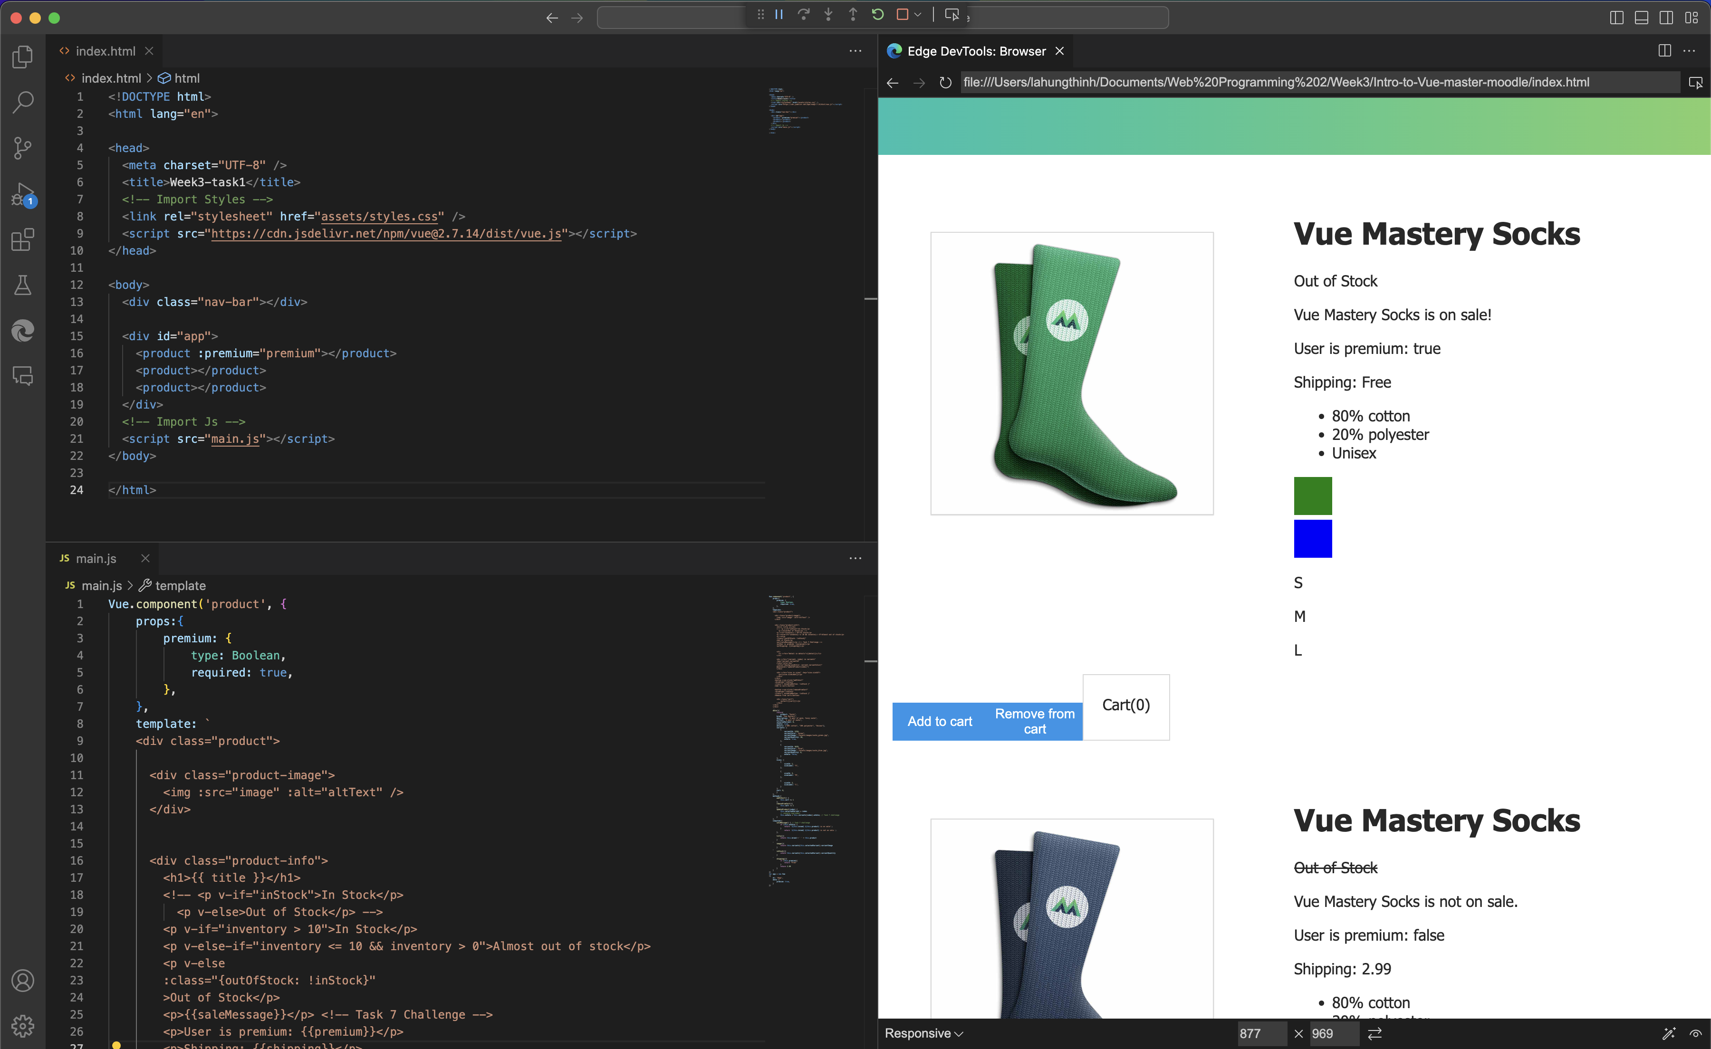

Figure 10: Lesson 8

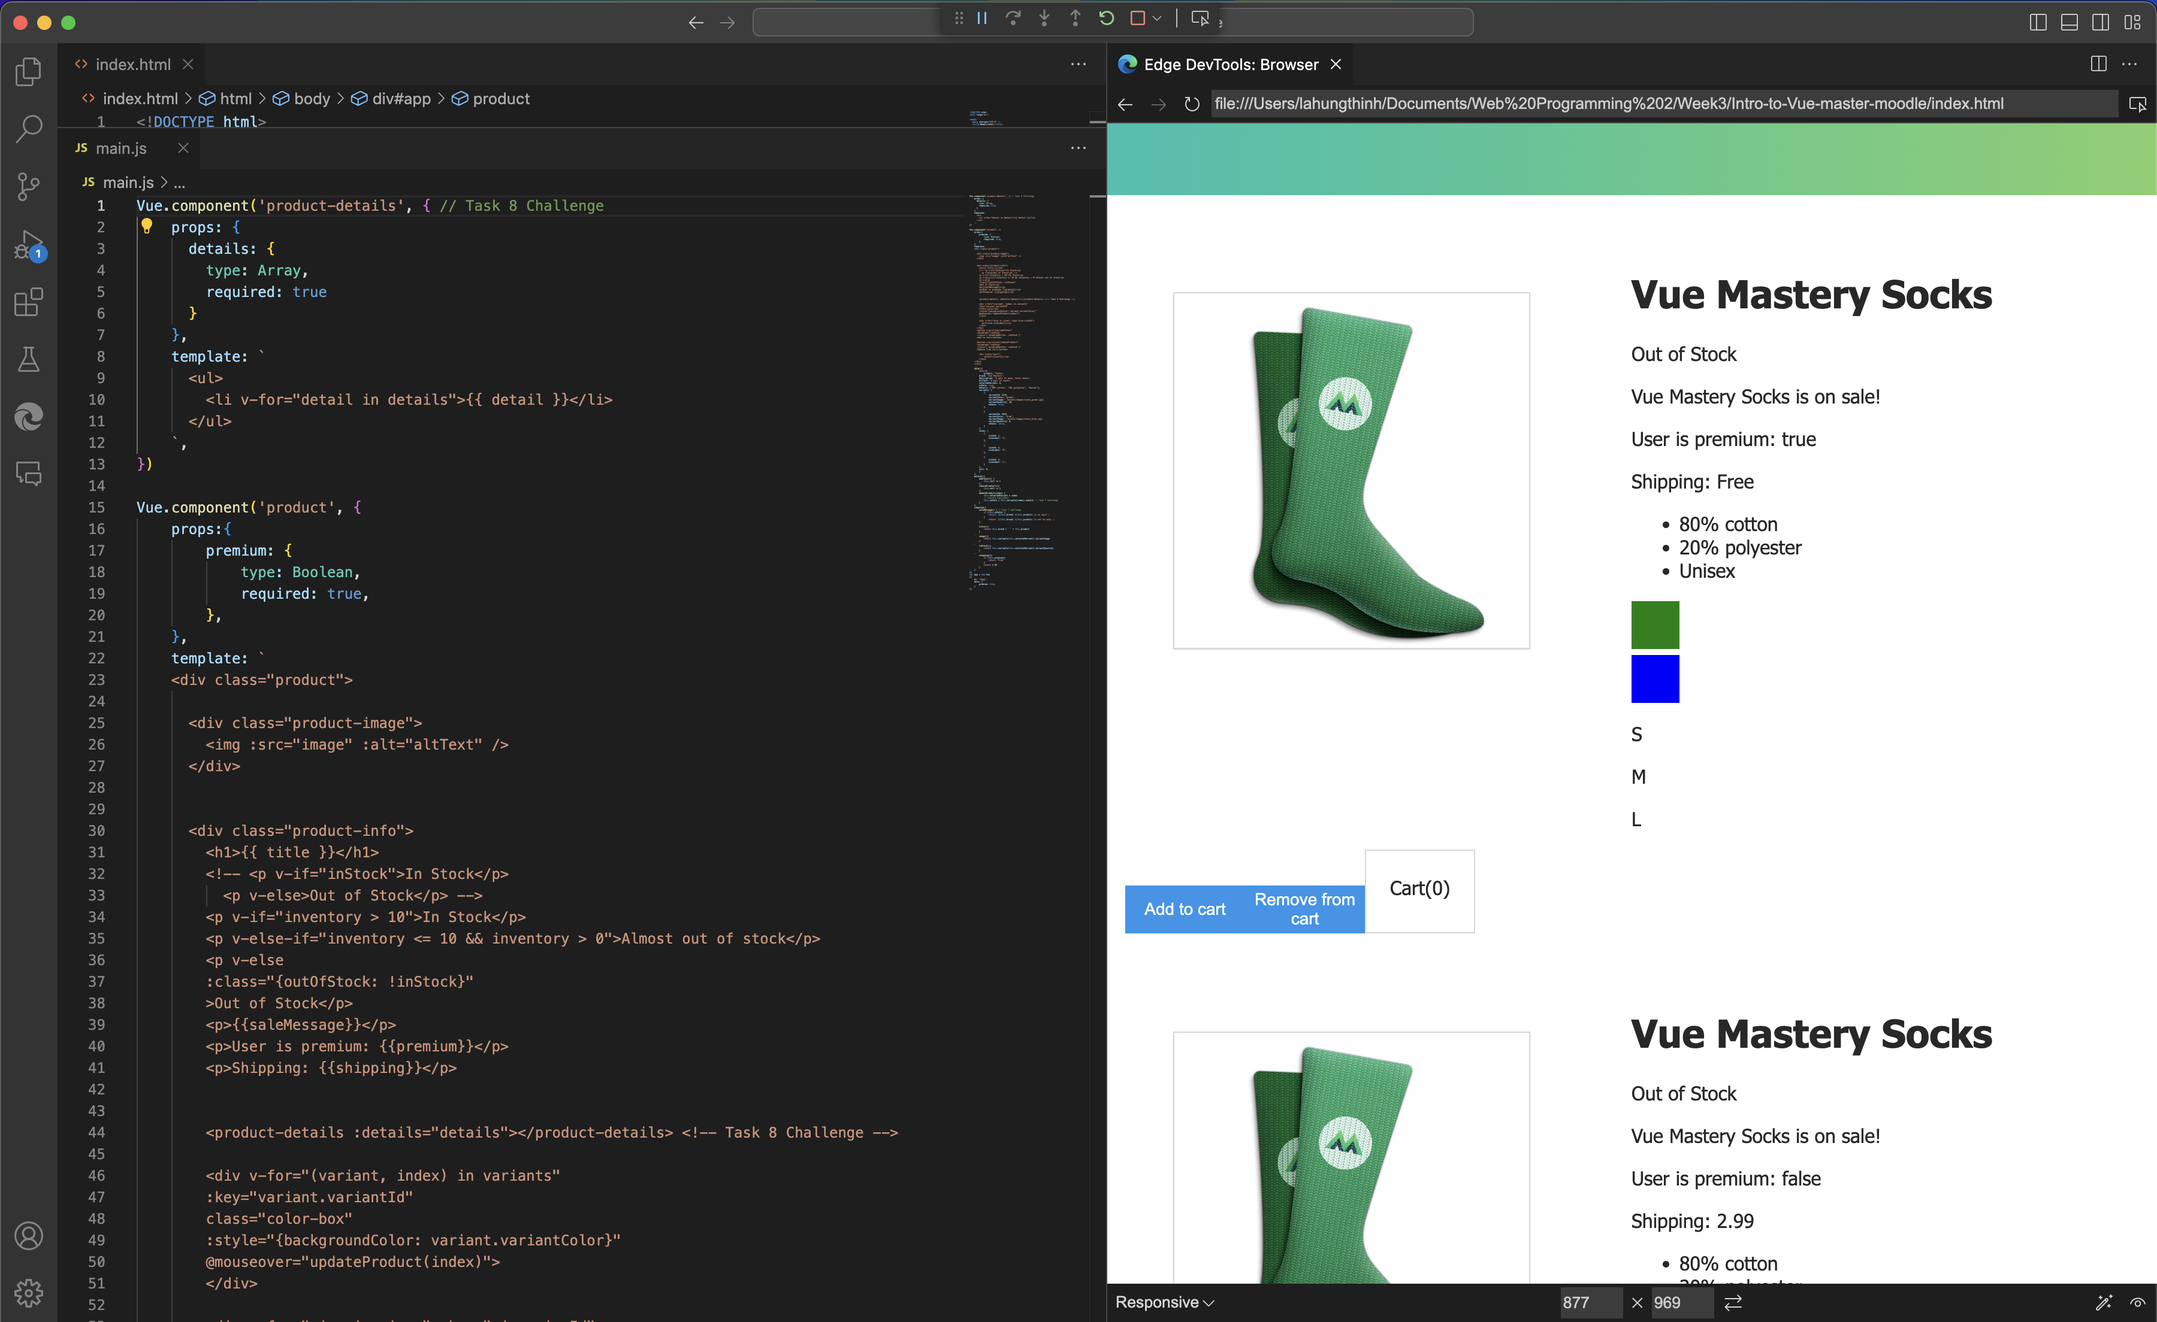

Figure 11: Lesson 8 Challenge

Task 9:

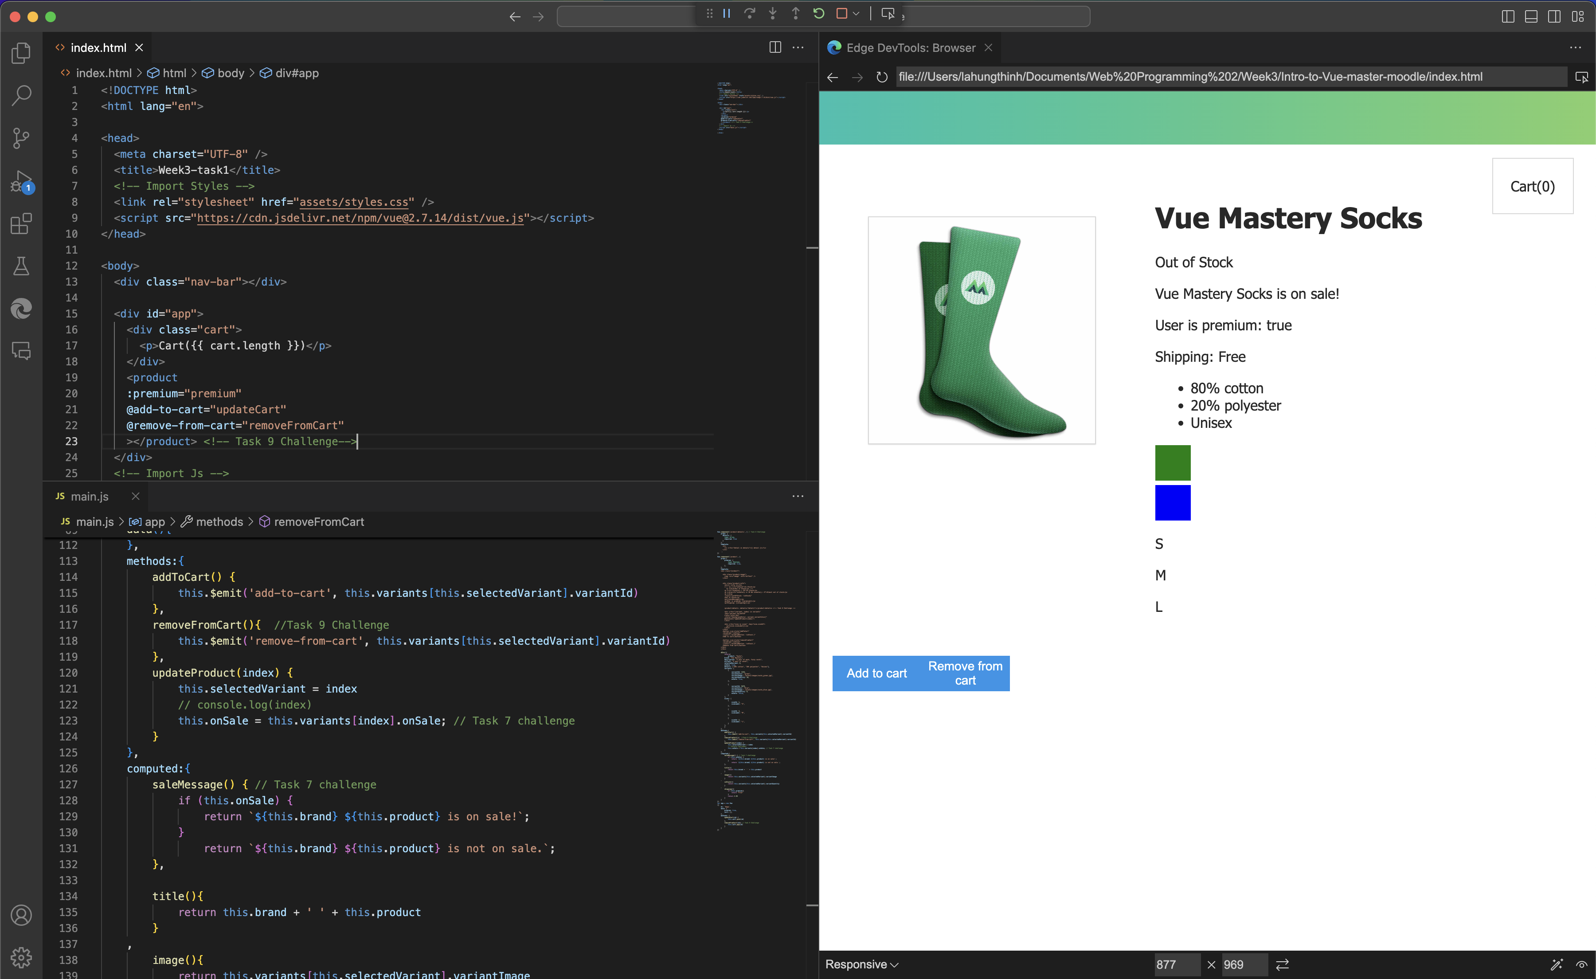

Figure 12: Lesson 9 + Challenge (Part 1)

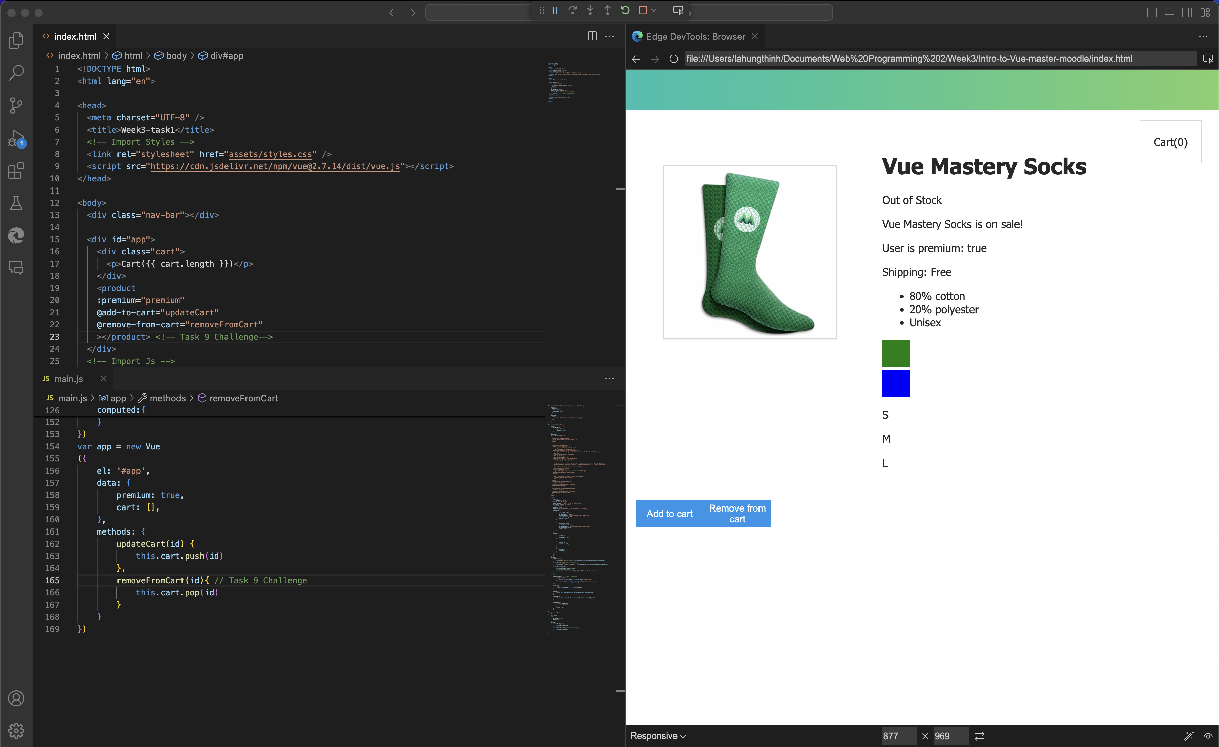

Figure 13: Lesson 9 + Challenge (Part 2)

Task 10:

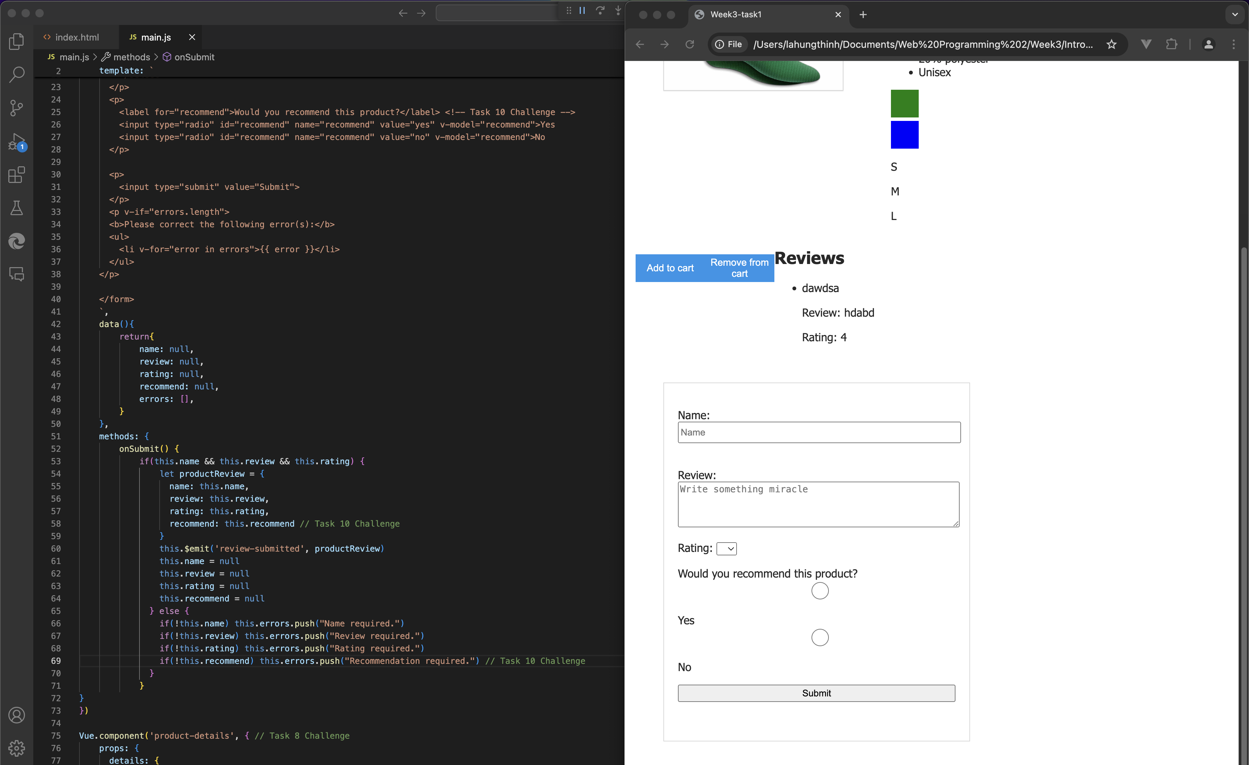

Figure 14: Lesson 10 + Challenge (Part 1)

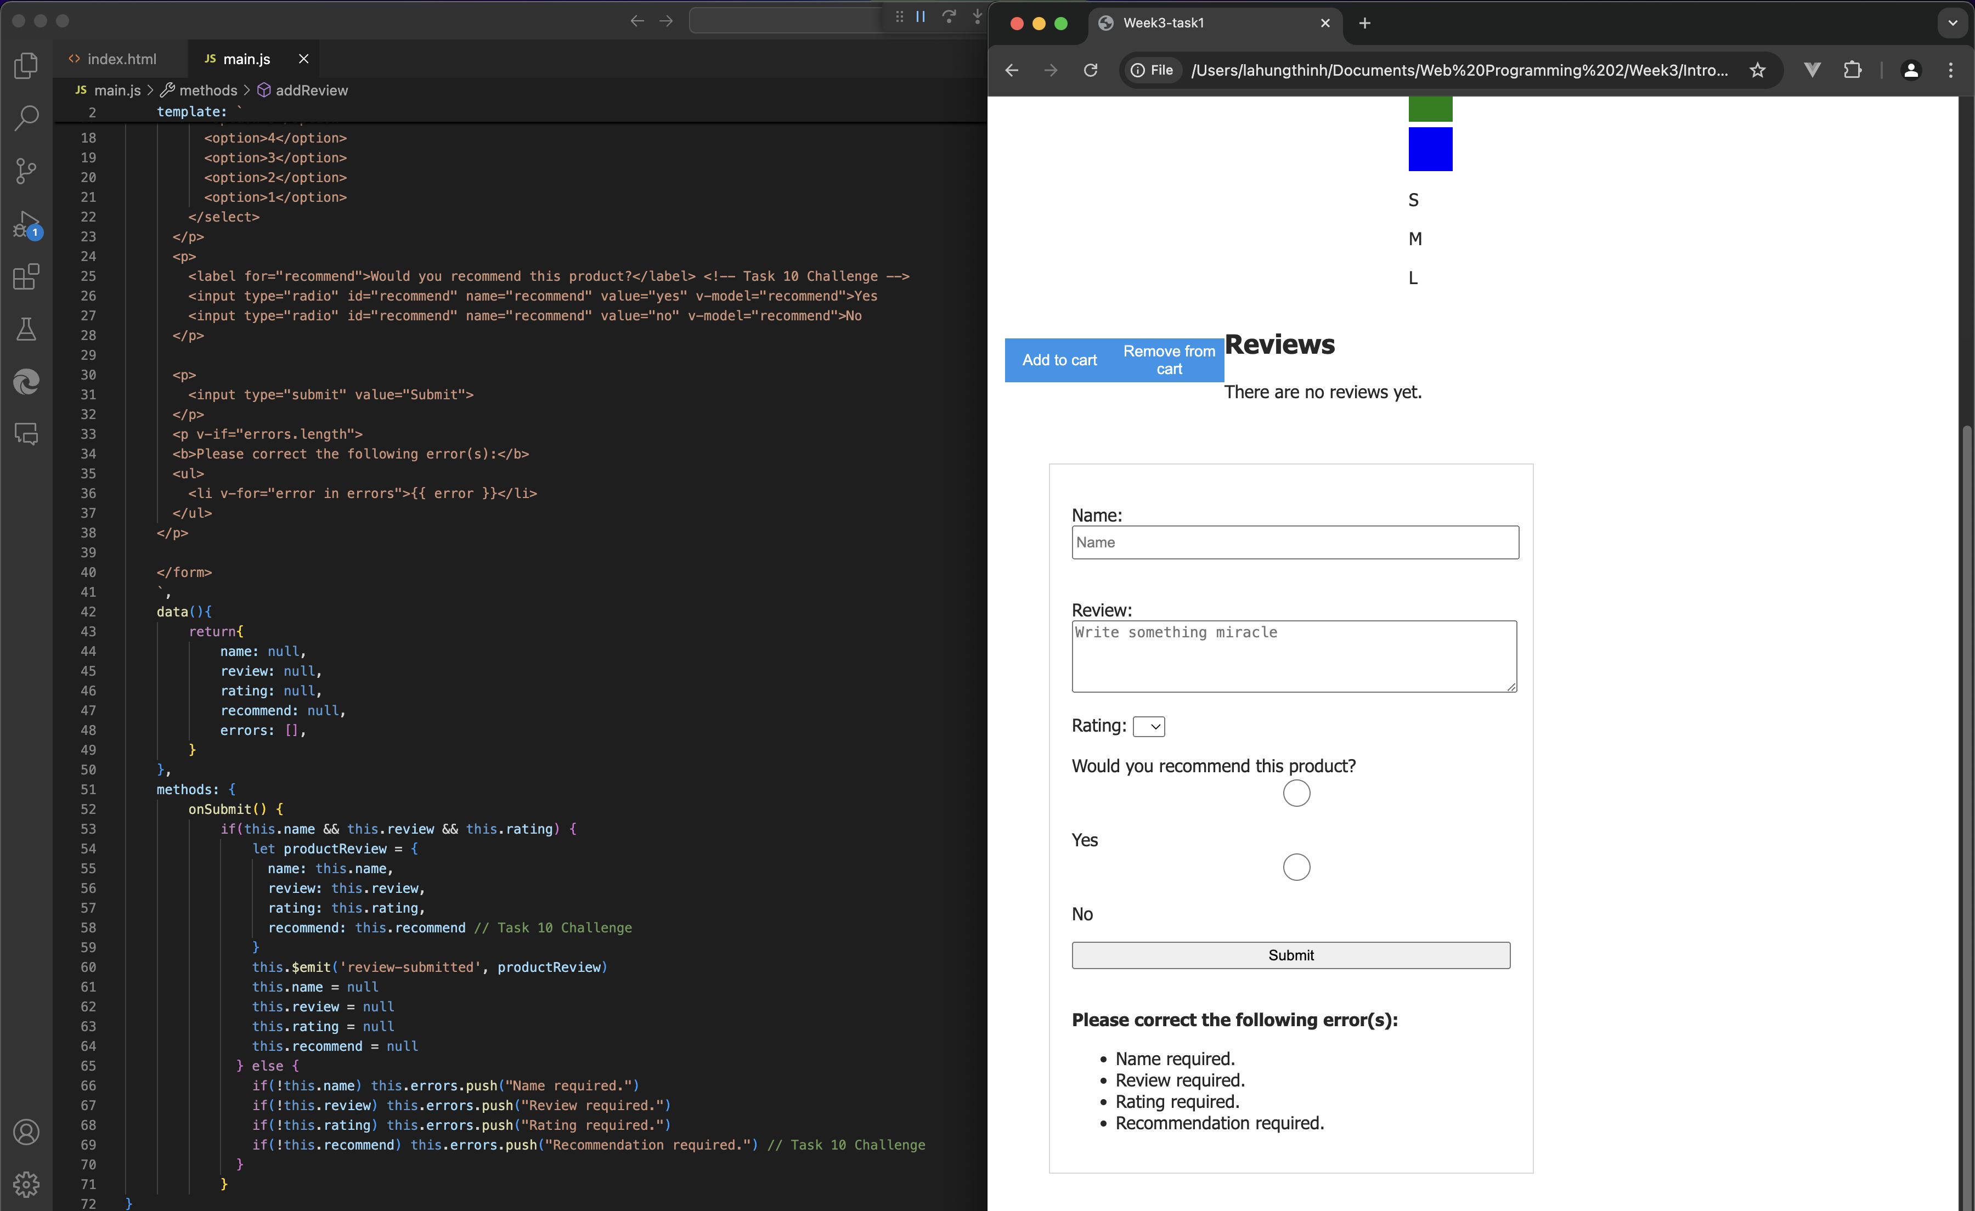

Figure 15. Lesson 10 + Challenge (Part 2)

Explanation:

Throughout these lessons, I discovered the benefits of organizing code into components, which allows for the creation of multiple products that share similar attributes. By using components, I can choose whether certain products inherit specific attributes while keeping the codebase flexible and maintainable. Additionally, I learned how to effectively move methods and computed properties into components, ensuring reusability and clean code structure.

In **Lesson 9**, I gained a deeper understanding of how array manipulation works, particularly with the .push and .pop methods. I realized that using .push appends elements to the end of an array, but more importantly, .pop removes the last element. This insight helped me solve an issue where my shopping cart’s quantity would turn negative if I spammed the remove button. By applying .pop, I was able to prevent the cart’s count from dropping below zero, effectively solving the problem I faced in earlier challenges.

Lastly, in **Lesson 10**, I worked on creating two radio buttons for user input. Although I initially encountered an issue where the radio buttons wouldn't display correctly on the screen, I managed to address this problem by focusing on validation. I successfully implemented error messages to notify users if they failed to provide a recommendation or meet other required fields. This taught me the importance of input validation and error handling in creating a more user-friendly interface.

**Introduction to MongoDB**

Task 2:

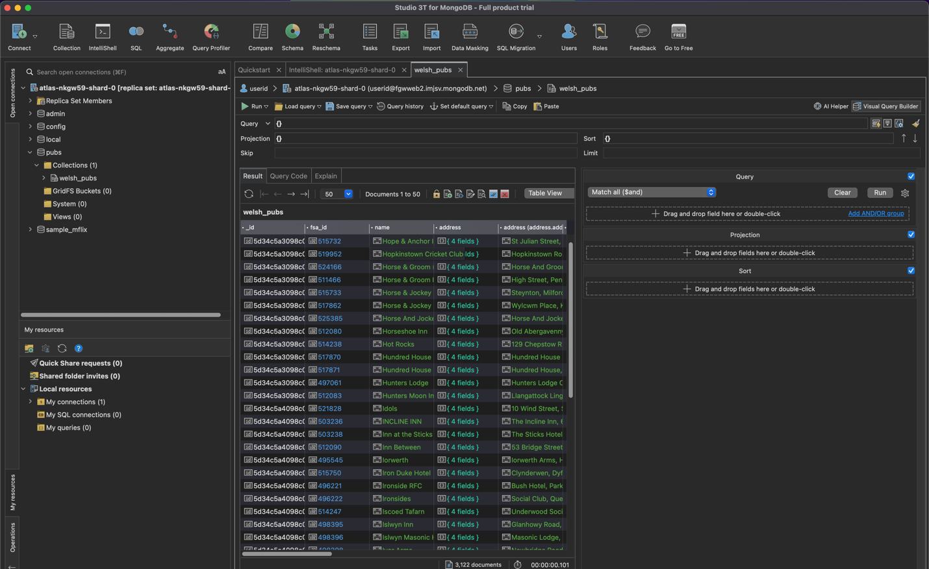

#### Figure 1: Lesson 1 Exercise 1

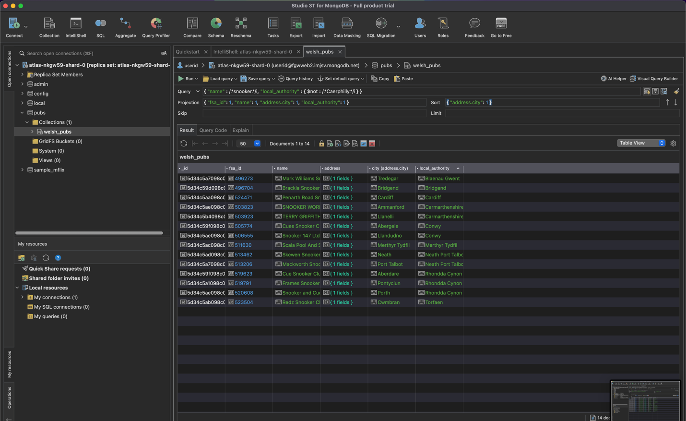

#### Figure 2: Lesson 1 Exercise 3

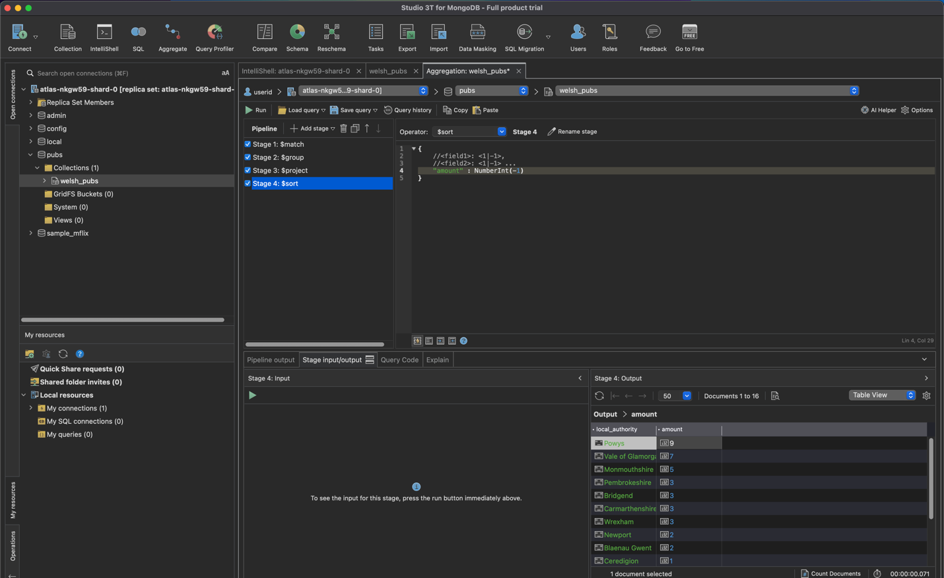

#### Figure 3: Lesson 5 Exercise 3

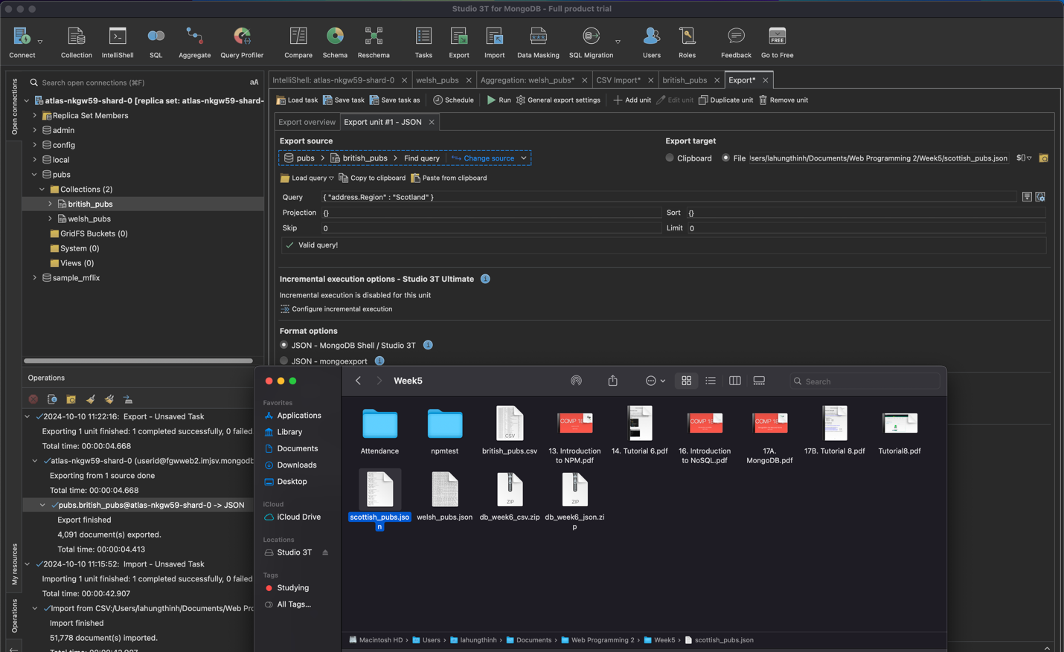

#### Figure 4: Lesson 6 Exercise 2

* Explanation:

NoSQL databases

* NoSQL databases are characterized by their ability to store data without requiring a fixed schema. This flexibility allows developers to store different types of data within a single database, making it easier to adapt to changing data models. They are also highly scalable, supporting horizontal scaling by distributing data across multiple servers or nodes, a feature particularly valuable for applications dealing with large datasets or high traffic. NoSQL databases are categorized into four main types: document-oriented, key-value stores, column-family stores, and graph databases.

MongoDB

* MongoDB is a document-oriented NoSQL database that stores data in a flexible, JSON-like format (BSON). This structure allows for the representation of complex data in a single document, without requiring multiple related tables as in a relational database. MongoDB’s dynamic schema enables developers to modify the data model as needed without the constraints of a rigid schema, facilitating rapid development and evolution of applications.
* Additionally, MongoDB is designed for scalability and high availability. It uses **sharding** to distribute data across multiple nodes, which ensures consistent performance as the dataset grows. Replication ensures that data is always available, even in cases of hardware or network failures. MongoDB also supports powerful querying capabilities and an aggregation framework, allowing for efficient data retrieval and manipulation.
* In summary, MongoDB’s flexible architecture and scalability make it well-suited for modern applications that require efficient data handling and adaptability to changing requirements.

Link to my Github: https://github.com/Synpesto/WebProgramming2